**附件1**

**鼓浪屿三丘田码头改建工程用海范围坐标表**

|  |  |  |  |  |  |  |  |
| --- | --- | --- | --- | --- | --- | --- | --- |
| 顶 点 坐 标（CGCS2000坐标系） | | | | | | | |
| 序号 | 北纬 | | 东经 | | 序号 | 北纬 | 东经 |
| 1 | 24°27′08.188″ | | 118°03′51.886″ | | 12 | 24°27′11.100″ | 118°03′53.096″ |
| 2 | 24°27′08.902″ | | 118°03′53.479″ | | 13 | 24°27′10.814″ | 118°03′52.457″ |
| 3 | 24°27′08.917″ | | 118°03′53.471″ | | 14 | 24°27′10.711″ | 118°03′52.512″ |
| 4 | 24°27′09.260″ | | 118°03′54.237″ | | 15 | 24°27′09.977″ | 118°03′50.872″ |
| 5 | 24°27′09.317″ | | 118°03′54.364″ | | 16 | 24°27′09.716″ | 118°03′51.023″ |
| 6 | 24°27′09.674″ | | 118°03′55.162″ | | 17 | 24°27′09.425″ | 118°03′51.181″ |
| 7 | 24°27′09.888″ | | 118°03′55.640″ | | 18 | 24°27′08.413″ | 118°03′51.761″ |
| 8 | 24°27′12.515″ | | 118°03′54.236″ | | 19 | 24°27′07.666″ | 118°03′55.089″ |
| 9 | 24°27′12.301″ | | 118°03′53.757″ | | 20 | 24°27′08.708″ | 118°03′57.416″ |
| 10 | 24°27′11.944″ | | 118°03′52.961″ | | 21 | 24°27′14.170″ | 118°03′54.496″ |
| 11 | 24°27′11.830″ | | 118°03′52.706″ | | 22 | 24°27′12.610″ | 118°03′52.613″ |
| 内部单元 | | 用海方式 | | 界址线 | | | 面积（公顷） |
| 人行栈桥、码头平台、趸船等 | | 透水构筑物 | | 1-2-3-…-18-1 | | | 0.8761 |
| 锚链系统、停泊水域 | | 港池、蓄水等 | | 4-19-20-21-22-10-9-8-7-6-5-4 | | | 0.8835 |
| 宗海 | |  | | 1-2-3-4-19-20-21-22-10-11-12-…-18-1 | | | 1.7596 |

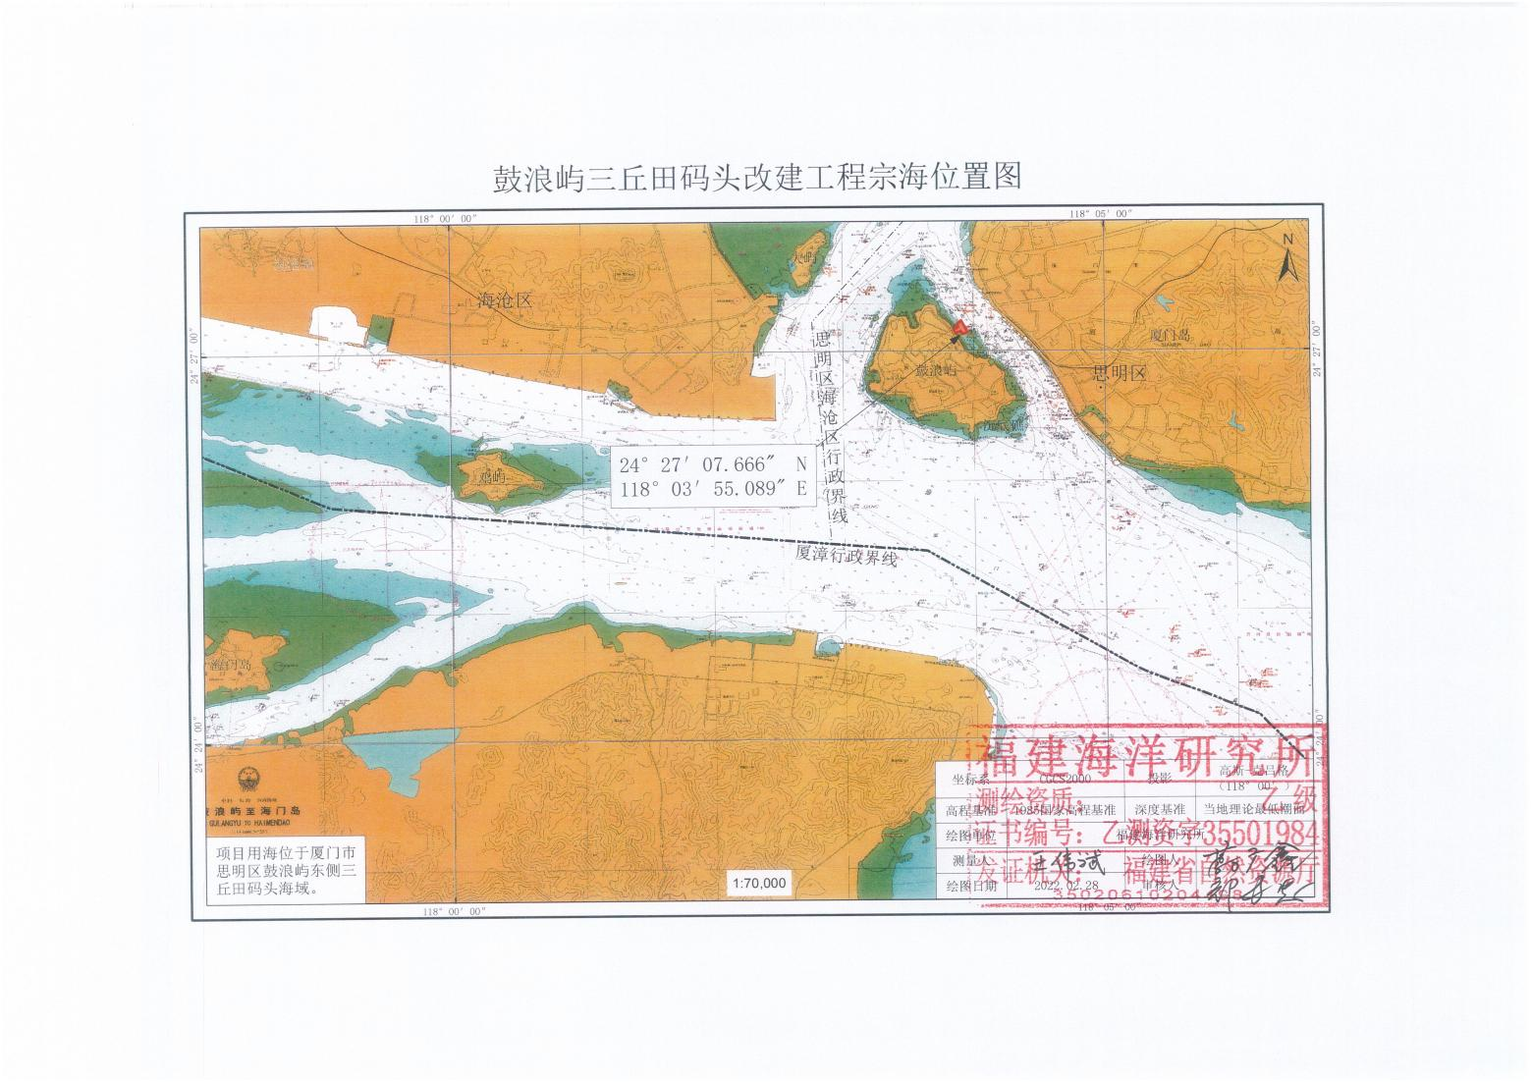**附件2**

